EXPERIMENT-3
3) Perform basic Image Handling and processing operations on the image is to read an image in python and Convert an Image to show outline using Canny function.
- CODE
- import cv2

- img = cv2.imread("photo.jpg")

- gray = cv2.cvtColor(img, cv2.COLOR_BGR2GRAY)

- edges = cv2.Canny(gray, 100, 200)

- cv2.imwrite("canny_outline.jpg", edges)

- print("Image outline created successfully")

b) INPUT
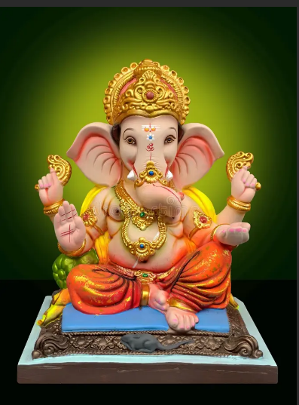
c) OUTPUT
